**Report*:*** *Fixing Two Select Visualizations*

*Category 1*

**Motivation:**

The original graph of [“Quarterly Report by Region”](http://mas-dse.github.io/DSE241/pages/imgs/full/tumblr_ntadud7h0b1sgh0voo1_1280.jpg) (we are assuming $ plotted on the y-axis denotes sales) violates the channel effectiveness principles. Specifically, the position channel is convoluted with the length channel to create difficulty assessing magnitude of the sales metric. Our goal is to improve this visualization so that an audience may yield more tangible insight.

**Task:**

Provided the initial visualization and the data behind it, we have constructed a new visualization that is easier to visually encode by properly using the position and length channels. In our new visualization, we want to answer the chosen visualization’s questions more effectively: which have been the most profitable regions, and how do they trend over the course of the year?

The new plot was created using R’s ggplot2 library.

**Visualization:**

Here we have used the same data to plot the distribution of sales by region over time:

***Chosen:***

***Ours:***

Sales are measured on a common numeric scale and are an ordered attribute. Additionally, as we assume “quarters” to be a time increment, the quarters themselves also form an ordered attribute. We leverage the *position* (both horizontal and vertical) channel on a common scale to demonstrate magnitude across both axes.

From there, the *length* and *angle* channels are able to capture trends associated with the sales metric. *Color* is then used as a channel to determine categorical difference between the regions.

**Assessment:**

Given the set of questions identified, we believe our visualization adequately addresses them while following the channel effectiveness principles. Our solution is significantly better than the predecessor and we can determine that both East and North are the most profitable regions with the East region surging towards the end of the year.

*Category 2*

**Motivation:**

The original graph of [“How $3.7 Trillion is Spent”](https://mas-dse.github.io/DSE241/pages/imgs/full/budget-bubble.png) violates the channel effectiveness principles. Specifically, the position channel is leveraged in contrast with the area channel. Both appear to be convoluted with the color channel as well. Our goal is to improve this visualization so that an audience may yield more tangible insight.

**Task:**

Provided the initial visualization and the data behind it, we have constructed a new visualization that is easier to visually encode by properly using the position, area and color channels. In our new visualization, we want to answer the chosen visualization’s questions more effectively: how has the U.S. budget spending changed over time, which are the most expensive sectors and how have they grown in the past year?

The new plot was created using R’s ggplot2 library.

**Visualization:**

Here we have used the same data to plot the distribution of cost sector budgets, and their growth over time:

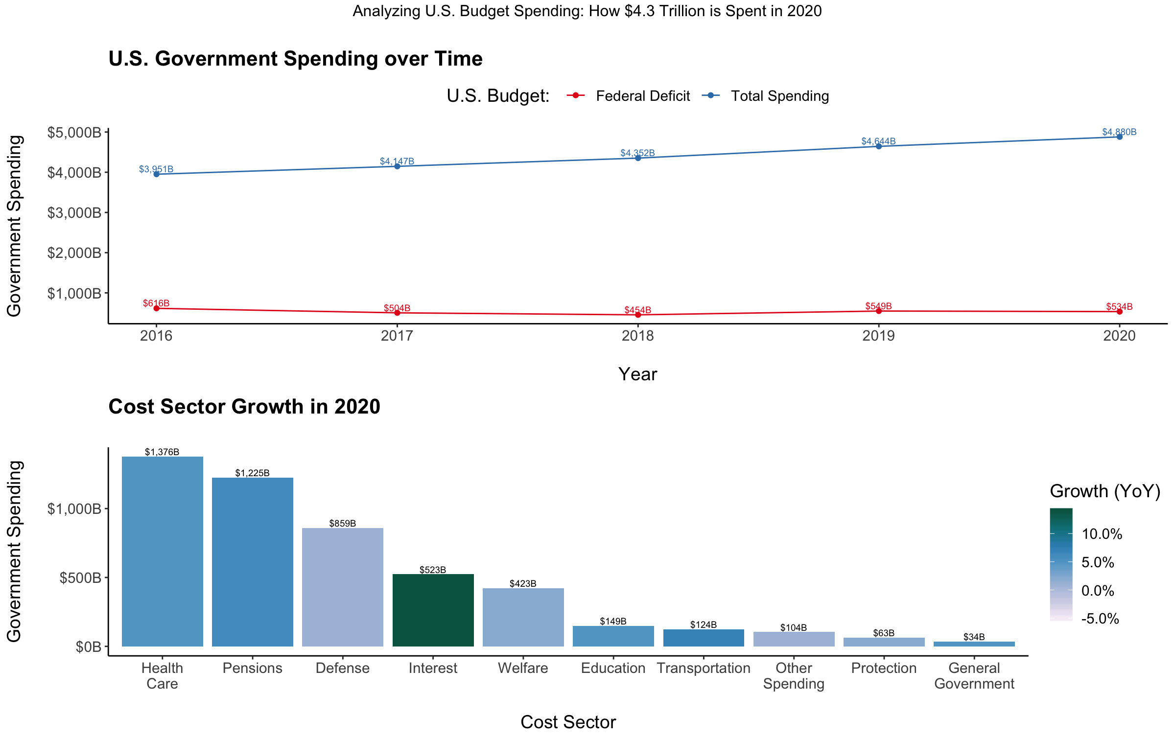

***Ours:***

***Chosen:***

Cost is measured on two separate numeric scales and is an ordered attribute. Additionally, years are a time-scaled ordered attribute and we used spatial-region to separate the categorical attributes. We leverage *position* in both plots (both horizontal and vertical in top, vertical in bottom) channel to demonstrate magnitude across both axes.

From there, the *length* and *angle* (area below) channels are able to capture trends associated with costs metric. *Color* hue is then used as a channel to determine categorical difference between the costs (top) and color saturation is used to visualize the magnitude of cost growth (bottom).

**Assessment:**

Given the set of questions identified, we believe our visualization adequately addresses them while following the channel effectiveness principles. Our solution is significantly better than the predecessor, incorporates more information, and we can determine that gross spending is rising, Healthcare is the most expensive sector, and the Interest paid on the Federal Deficit is rising rapidly.